**CDAC Mumbai PG-DAC August 24**

**Assignment No- 5**

1. Create a base class BankAccount with methods like deposit() and withdraw(). Derive a class SavingsAccount that overrides the withdraw() method to impose a limit on the withdrawal amount. Write a program that demonstrates the use of overridden methods and proper access modifiers & return the details.

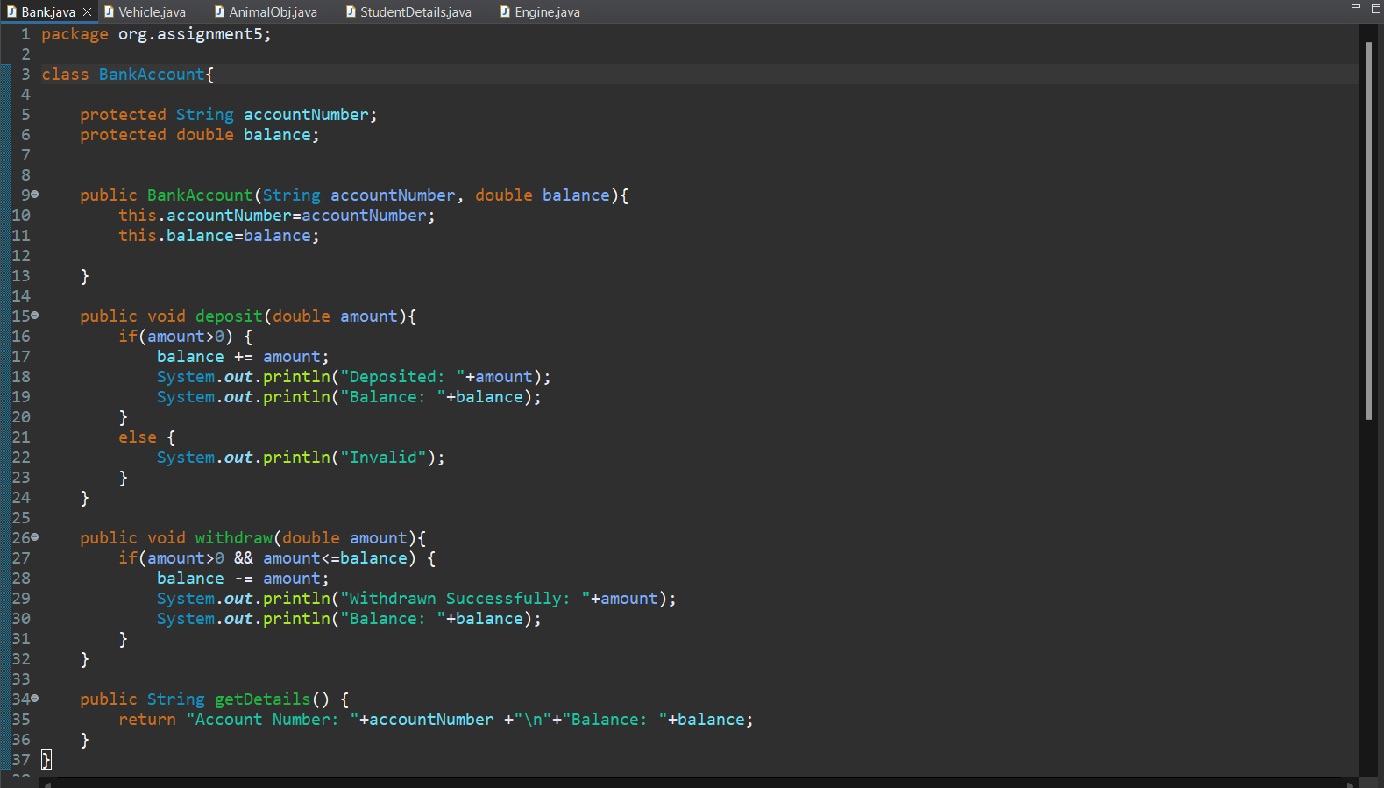

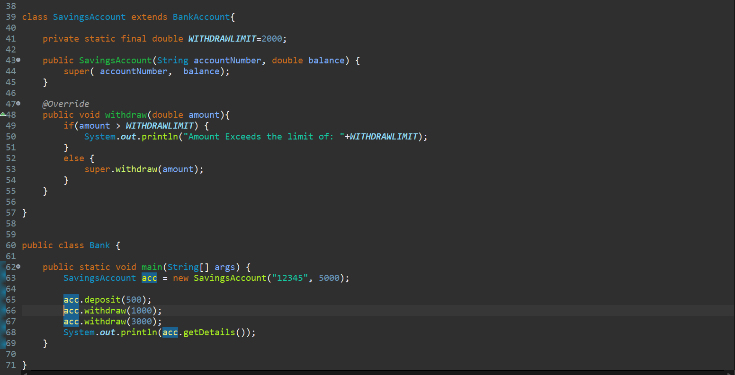

1. Create a base class Vehicle with attributes like make and year. Provide a constructor in Vehicle to initialize these attributes. Derive a class Car that has an additional attribute model and write a constructor that initializes make, year, and model. Write a program to create a Car object and display its details.

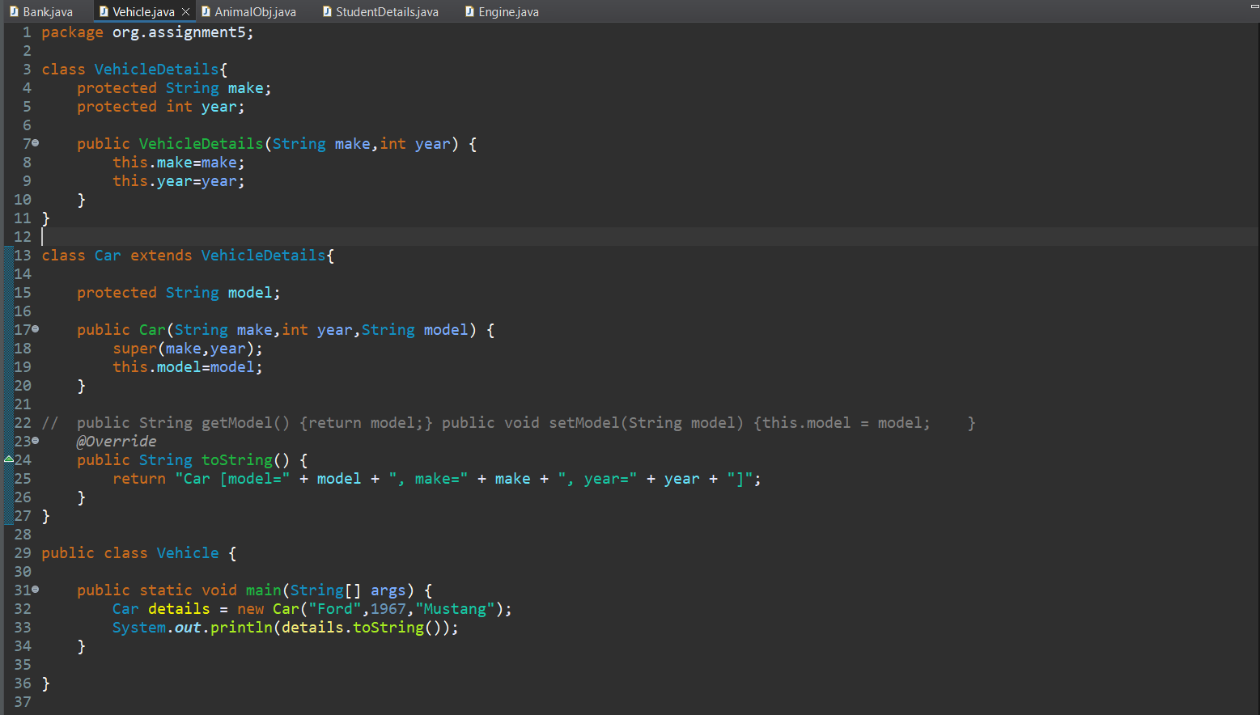

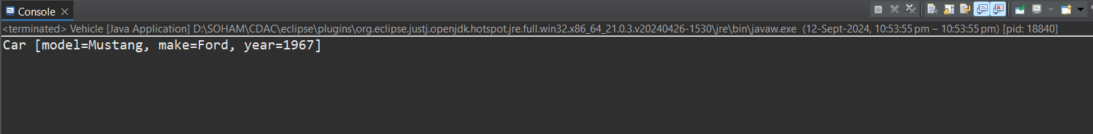

1. Create a base class Animal with attributes like name, and methods like eat() and sleep(). Create a subclass Dog that inherits from Animal and has an additional method bark(). Write a program to demonstrate the use of inheritance by creating objects of Animal and Dog and calling their methods.

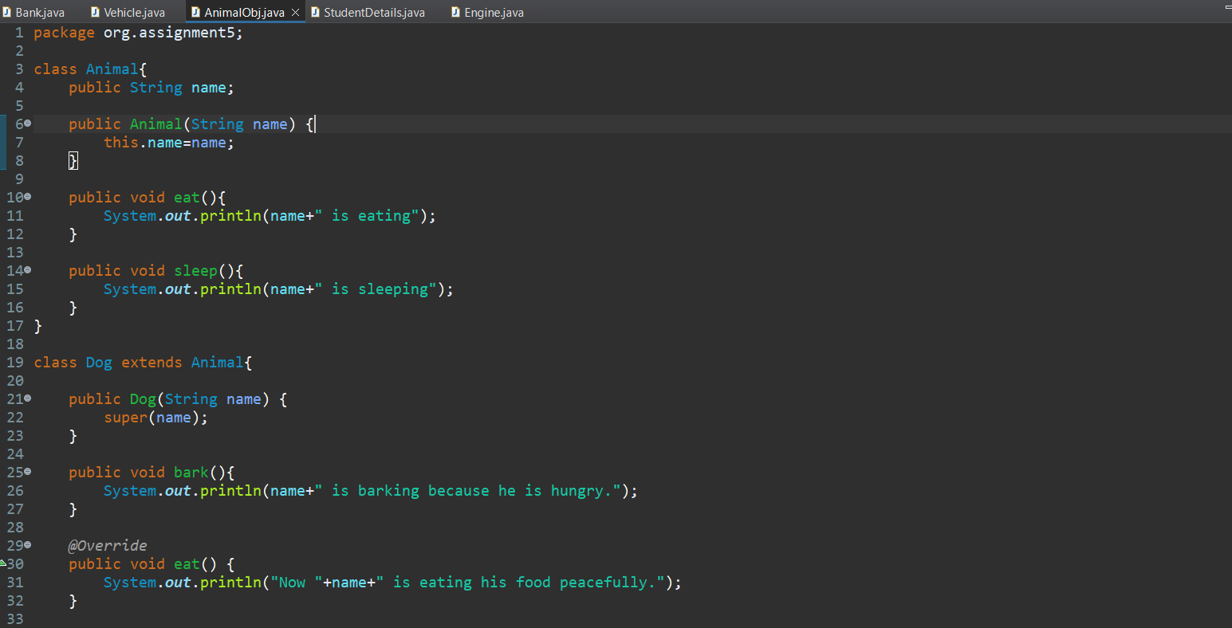

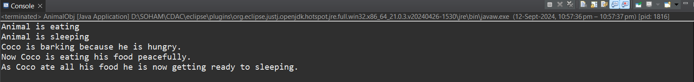

1. Build a class Student which contains details about the Student and compile and run its

instance.

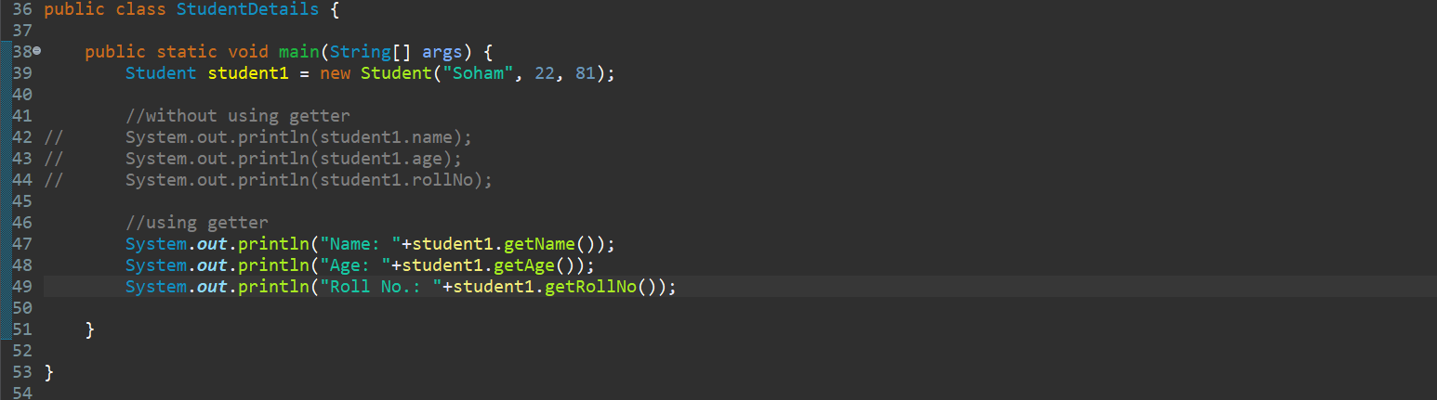

1. Write a Java program to create a base class Vehicle with methods startEngine() and stopEngine(). Create two subclasses Car and Motorcycle. Override the startEngine() and stopEngine() methods in each subclass to start and stop the engines differently.

